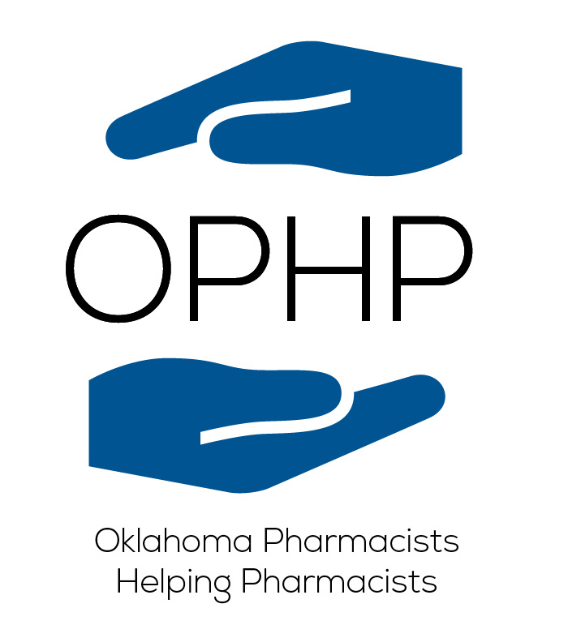

**CONDITIONS OF FINANCIAL AID**

Please read, sign and date the following:

I acknowledge that I am applying for financial assistance for monitoring from OPHP

I acknowledge that approval for such assistance is required.

I acknowledge that assistance will be based upon:

1. Financial need as established by information received in the application for assistance. The applicant must submit the most current income tax statement, or other proof of income. It is understood the application will not be processed without this information.
2. Availability of funds.
3. Your letter describing your motivation and intent for treatment. The letter should include how your addiction has impacted you, your family, employment, physical and emotional well-being, and other areas of your life.
4. Willingness to follow continuing care recommendations.

I acknowledge that my receipt of financial aid from OPHP is confidential.

I acknowledge that I may be eligible to receive financial aid from OPHP one time only.

I declare that I have honestly and correctly completed this financial aid application. I understand and give consent to OPHP to contact me and/or others for verification of the information provided. I agree to notify the OPHP in writing if there are any changes regarding my financial situation.

I acknowledge that verification of this application may require disclosure that I have applied for treatment for chemical dependency, and agree to sign the release of information form as necessary to complete this verification.

In the event that I have failed to disclose any assets or income, I acknowledge that I will be ineligible for financial assistance from OPHP

Signature of Applicant Date